Data Formats

🧾 What Are Data Formats?
# Source: AI Source: Provided by: [Data Path: Persons Table -> ID Column: 1, Name_En Column: Motasem Essam] -> From: [ChatGPT] on [2/12/2026]
Data formats define how data is structured and sent between client and server in an HTTP request or response.
👉 They make sure both sides can understand the data correctly.

✅ Simple Definition:
# Source: AI Source: Provided by: [Data Path: Persons Table -> ID Column: 1, Name_En Column: Motasem Essam] -> From: [ChatGPT] on [2/12/2026]
A data format is a standard way of organizing data so systems can read and process it.

🧠 Real-Life Analogy:
# Source: AI Source: Provided by: [Data Path: Persons Table -> ID Column: 1, Name_En Column: Motasem Essam] -> From: [ChatGPT] on [2/12/2026]
Think of data formats like languages 🌍:
● JSON → like English
● XML → like a formal document
● Form Data → like filling a paper form
👉 If both sides speak the same format → communication works

🔁 How Data Formats Work
# Source: AI Source: Provided by: [Data Path: Persons Table -> ID Column: 1, Name_En Column: Motasem Essam] -> From: [ChatGPT] on [2/12/2026]
- 👤 Client sends data (e.g., form or API request)
- 📦 Data is formatted (JSON, form-data, etc.)
- 🌐 Sent inside HTTP request
- ⚙️ Server reads and parses the format
- 📥 Server processes and responds

📊 Common Data Formats

🔹 1. JSON (JavaScript Object Notation)
# Source: AI Source: Provided by: [Data Path: Persons Table -> ID Column: 1, Name_En Column: Motasem Essam] -> From: [ChatGPT] on [2/12/2026]
👉 Most used format in modern APIs
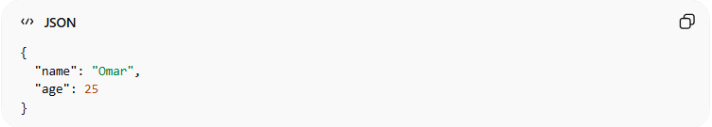
{
"name": "Omar",
"age": 25
}
● Lightweight and easy to read
● Used in APIs and mobile apps
● Works with almost all languages

🔹 2. XML (eXtensible Markup Language)
# Source: AI Source: Provided by: [Data Path: Persons Table -> ID Column: 1, Name_En Column: Motasem Essam] -> From: [ChatGPT] on [2/12/2026]
👉 More strict and verbose
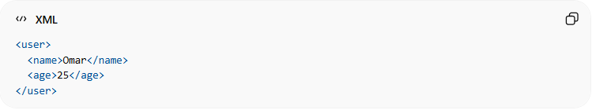
<user>
<name>Omar</name>
<age>25</age>
</user>
● Uses tags like HTML
● Less common today (replaced mostly by JSON)

🔹 3. Form Data (HTML Forms)
# Source: AI Source: Provided by: [Data Path: Persons Table -> ID Column: 1, Name_En Column: Motasem Essam] -> From: [ChatGPT] on [2/12/2026]
👉 Used when submitting forms
Example (key-value pairs):
name=Omar&age=25
● Used in HTML forms
● Common in POST requests

🔹 4. Plain Text
# Source: AI Source: Provided by: [Data Path: Persons Table -> ID Column: 1, Name_En Column: Motasem Essam] -> From: [ChatGPT] on [2/12/2026]
👉 Simple text data
Hello World
● No structure
● Used for simple responses

📤 Example HTTP Request (JSON)
# Source: AI Source: Provided by: [Data Path: Persons Table -> ID Column: 1, Name_En Column: Motasem Essam] -> From: [ChatGPT] on [2/12/2026]
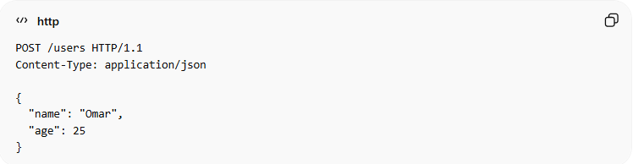
POST /users HTTP/1.1
Content-Type: application/json

{
"name": "Omar",
"age": 25
}
● Content-Type tells the server the format
● Data is sent in JSON

📥 Example HTTP Response (JSON)
# Source: AI Source: Provided by: [Data Path: Persons Table -> ID Column: 1, Name_En Column: Motasem Essam] -> From: [ChatGPT] on [2/12/2026]
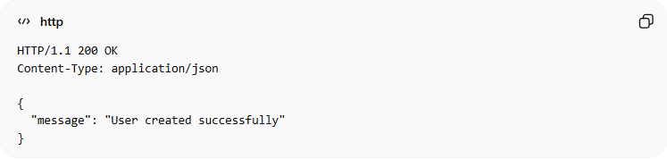
HTTP/1.1 200 OK
Content-Type: application/json

{
"message": "User created successfully"
}

📌 Content-Type Header (VERY IMPORTANT 🔥)
# Source: AI Source: Provided by: [Data Path: Persons Table -> ID Column: 1, Name_En Column: Motasem Essam] -> From: [ChatGPT] on [2/12/2026]
This header tells the server what format is being used:
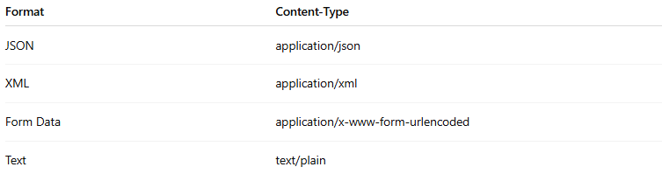
Format | Content-Type
JSON | application/json
XML | application/xml
Form Data | application/x-www-form-urlencoded
Text | text/plain

🔗 Relation to Other Topics
# Source: AI Source: Provided by: [Data Path: Persons Table -> ID Column: 1, Name_En Column: Motasem Essam] -> From: [ChatGPT] on [2/12/2026]
● HTTP Methods → define the action
● Data Formats → define how data is sent
● Headers → specify the format (Content-Type)
● APIs → rely heavily on data formats

💻 Simple PHP Example
# Source: AI Source: Provided by: [Data Path: Persons Table -> ID Column: 1, Name_En Column: Motasem Essam] -> From: [ChatGPT] on [2/12/2026]
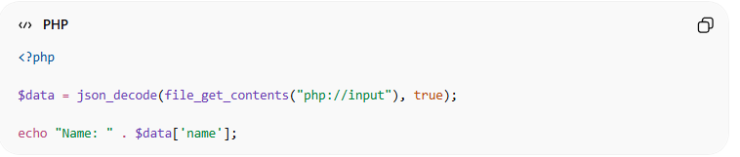
<?php

$data = json_decode(file_get_contents("php://input"), true);

echo "Name: " . $data['name'];
● Reads JSON data from request
● Converts it into PHP array
● Access data easily

🎯 Key Idea
# Source: AI Source: Provided by: [Data Path: Persons Table -> ID Column: 1, Name_En Column: Motasem Essam] -> From: [ChatGPT] on [2/12/2026]
👉 Data format = structure of data
👉 It ensures both client and server understand each other

🎓 Final Mental Model
# Source: AI Source: Provided by: [Data Path: Persons Table -> ID Column: 1, Name_En Column: Motasem Essam] -> From: [ChatGPT] on [2/12/2026]
● JSON → most common in modern APIs
● XML → older structured format
● Form Data → used in HTML forms
👉 Without data formats → communication breaks

